INFO-6068 Status Meeting Minutes – Team Pro-Test

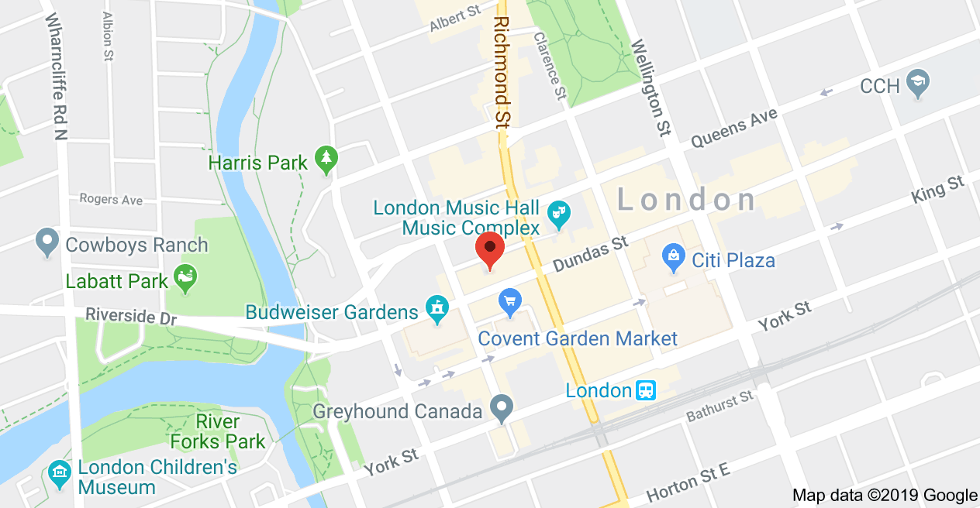

|  |  |  |  |
| --- | --- | --- | --- |
| Project: |  | | |
| **Project Manager:** | Lyan Limjap | **Business Responsible:** |  |
| Date: | 03-Oct-2019 | **Phase:** |  |
| Time: | 6:00pm | Location: | Fanshawe Downtown Campus – Room 415  130 Dundas Street  London ON |
| Prepared by: | Mrinal Chopra | Schedule: | **From:** 6:00pm  **To:** 7:00pm |

| Attendees (Present, Absent) | | | | | |
| --- | --- | --- | --- | --- | --- |
| Invited | Attended | Invited | Attended | Invited | Attended |
| Francisco Gomez | **√** |  |  |  |  |
| Ralph Anonuevo | **√** |  |  |  |  |
| Lyan Joy Limjap | **√** |  |  |  |  |
| Daniel Gilbert | **√** |  |  |  |  |
| Mrinal Chopra | **√** |  |  |  |  |
| Rose Maria George | **√** |  |  |  |  |
| Anand Karithadathil Baby | **√** |  |  |  |  |

| Objective(s): |
| --- |
| 1. Review Test Strategy 2. Discuss Code Review and Static Code Analysis Possibilities 3. Discuss Progress Reports and Status Reports 4. Discuss how to move forward with Test Cases 5. Discuss how to do Boundary Value Analysis and Equivalence Partitioning for Data Entries |

| Agenda/Meeting Highlights | |
| --- | --- |
| Topic # | Agenda/Meeting Highlights: |
|  | Code Review and Static Code Analysis not applicable for this project |
|  | Progress and Status Reports to be produced at later stages of the project |
|  | Test Cases will be preceded by Use Cases |
|  | Will analyze SQL database to asses boundary value analysis |
|  |  |
|  |  |
|  |  |
|  |  |
|  |  |
|  |  |

| Action/Issues List | | | | | |
| --- | --- | --- | --- | --- | --- |
| # | Date | Actions | Owner | Target Date | Action Status |
|  | October 3, 2019 | Review Use Cases: Basic Flow, Alternate Flow, Exception Flow | Project team | 10-10-19 | Open |
|  | October 3, 2019 | Prepare Agenda for next meeting | Scribe | 10-10-19 | Open |
|  | October 3, 2019 | Update Test Strategy | Project team | 10-10-19 | Open |
|  | October 3, 2019 | Update Project Plan | Project Manager | 10-10-19 | Open |
|  |  |  |  |  |  |
|  |  |  |  |  |  |
|  |  |  |  |  |  |
|  |  |  |  |  |  |
|  |  |  |  |  |  |
|  |  |  |  |  |  |
|  |  |  |  |  |  |
|  |  |  |  |  |  |

| Next Meeting | | |
| --- | --- | --- |
| Date | Room | Duration |
| October 10, 2019 | Room 415 LBD | 6:00pm – 7:00pm |